Reference

MlModel building : <https://docs.microsoft.com/en-us/azure/machine-learning/tutorial-first-experiment-automated-ml>

Consume Model : <https://docs.microsoft.com/en-us/azure/machine-learning/how-to-consume-web-service#call-the-service-c>

Dataset : <https://archive.ics.uci.edu/ml/datasets/bank+marketing>

**Abstract**

Form Design

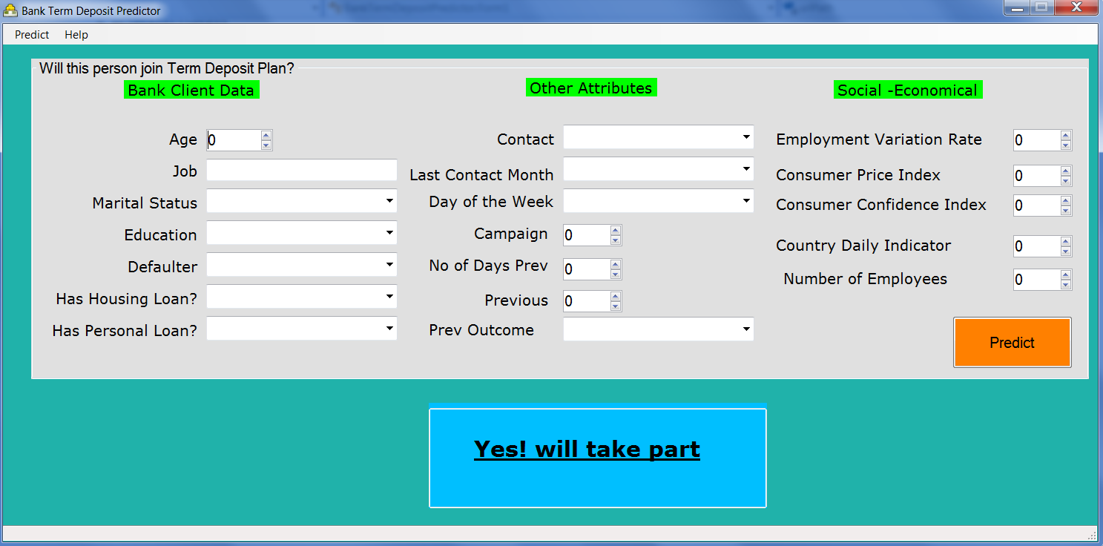

Table Design

ER Diagram

Data Collection

Data Preprocessing

ML Model Selection

**Dataset**

Bank Marketing Dataset

**The dataset is taken from** <https://archive.ics.uci.edu/ml/datasets/bank+marketing>

**Explain data set using** <https://archive.ics.uci.edu/ml/datasets/bank+marketing>

|  |  |
| --- | --- |
| Age | Account holder age |
| Job | Job Title |
| Marital | Marital Status |
| Education | Highest education qualification |
| Default | Is the person a loan defaulter |
| Housing |  |
| Loan |  |
| Contact |  |
| Month |  |
| day_of_week |  |
| Duration |  |
| Campaign |  |
| Pdays |  |
| Previous |  |
| Poutcome |  |
| emp.var.rate |  |
| cons.price.idx |  |
| cons.conf.idx, |  |
| euribor3m, |  |
| nr.employed |  |
| y | The objective column tells if the client will subscribe to term deposit |

**Sample Fact from the dataset**

|  |  |
| --- | --- |
| Age | 57 |
| Job | Technician |
| Marital | Married |
| Education | high.school |
| Default | No |
| Housing | No |
| Loan | Yes |
| Contact | Cellular |
| Month | May |
| day_of_week | Mon |
| Duration | 371 |
| Campaign | 1 |
| Pdays | 999 |
| Previous | 1 |
| Poutcome | Failure |
| emp.var.rate | -1.8 |
| cons.price.idx | 92.89299999999999 |
| cons.conf.idx, | -46.2 |
| euribor3m, | 1.2990000000000002 |
| nr.employed | 5099.1 |
| y | no |

**Creating Azure Machine Learning**

1. Provision Azure Machine Learning Service

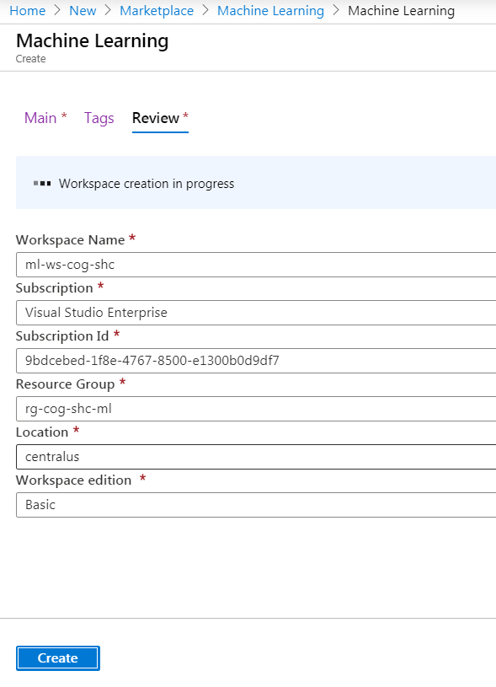

Provisioned Resources

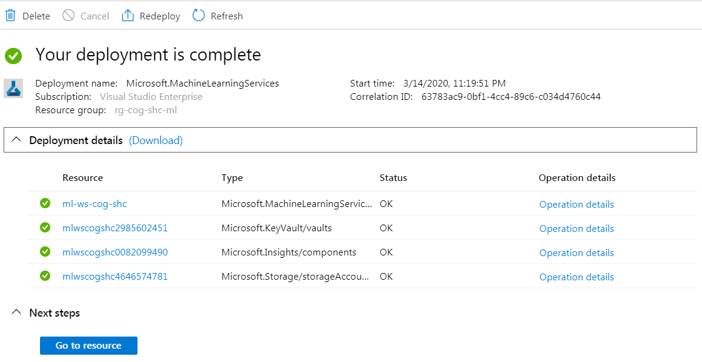

Upgrading to Enterprise (preview)

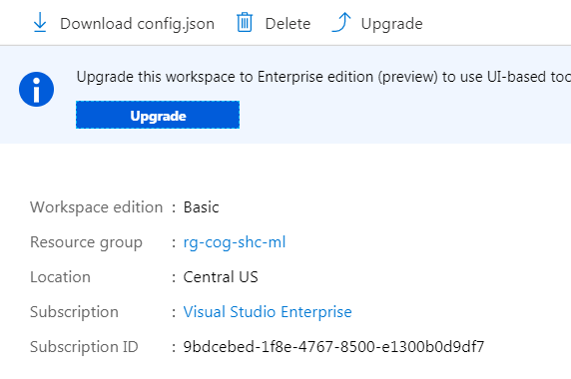

Machine Learning Process

Azure Machine Learning helps you build, train, deploy, and manage your models at cloud scale.

|  |  |
| --- | --- |
|  | **Register data**  Reference data from storage to easily access during model training and explore using summary statistics. |
|  | **Train models**  Use machine learning algorithms with training data to create models. |
|  | **Evaluate models**  Find the best model using test data. |
|  | **Deploy models**  Deploy model as a web service in the Azure cloud, or to IoT Edge devices. |

Login to ML Workspace by navigating to <https://ml.azure.com/selectWorkspace>

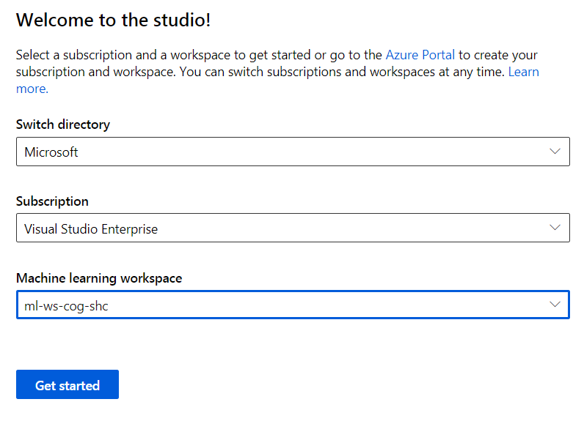

Proceed with Automated ML

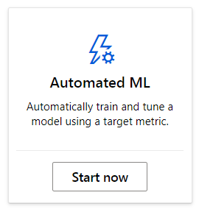

Create Dataset

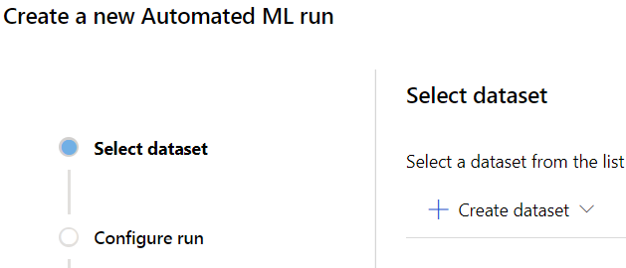

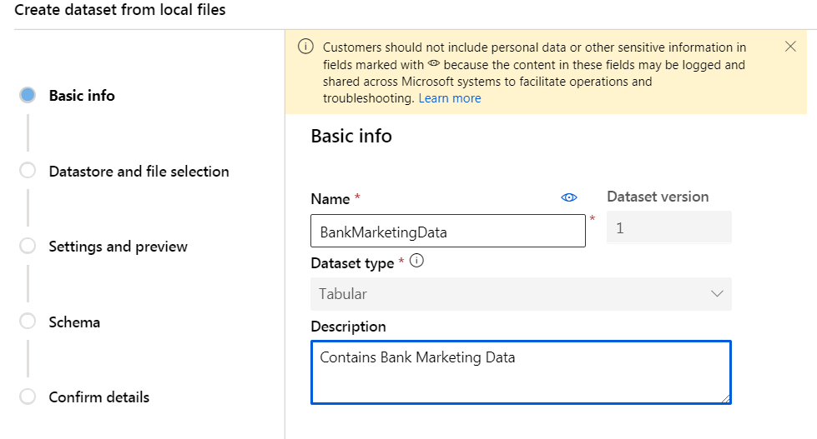

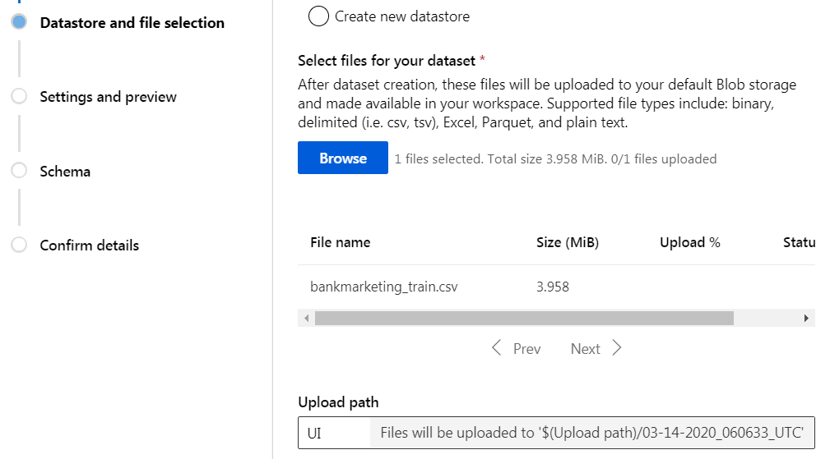

The data gets uploaded to the predefined storage, after that the dataset provides the preview of the Bank Marketing Data.

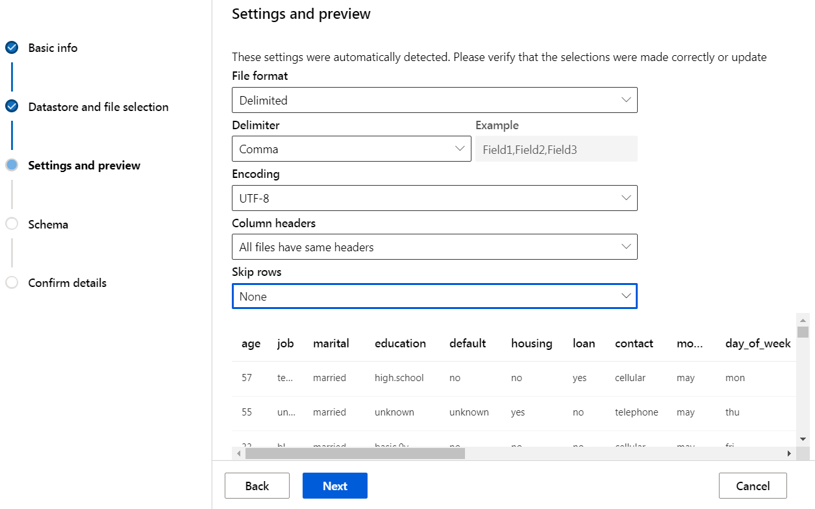

Exclude Feature of less importance ‘Day of Week’ has no impact in deciding if the customer has subscribed for a term deposit.

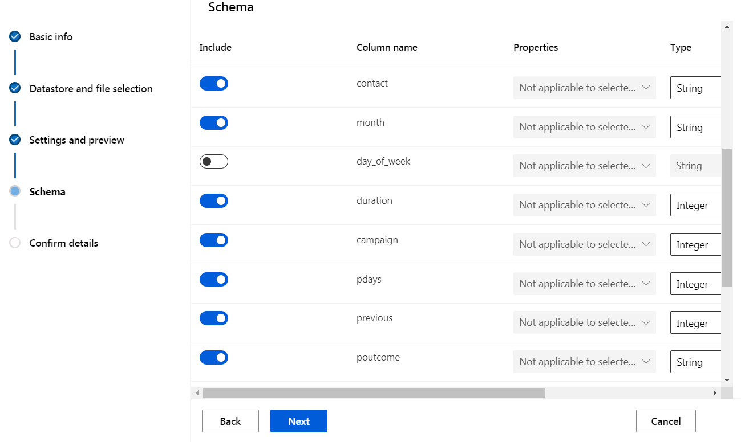

Dataset has been successfully created

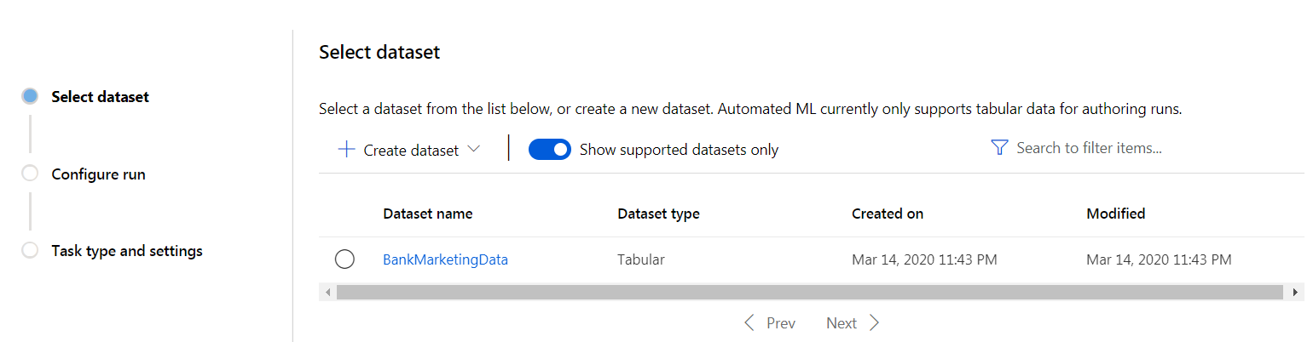

Select the Cluster for Machine Learning Model to Run

The Machine Name is mlvm2

username is mlvm2user1

password :

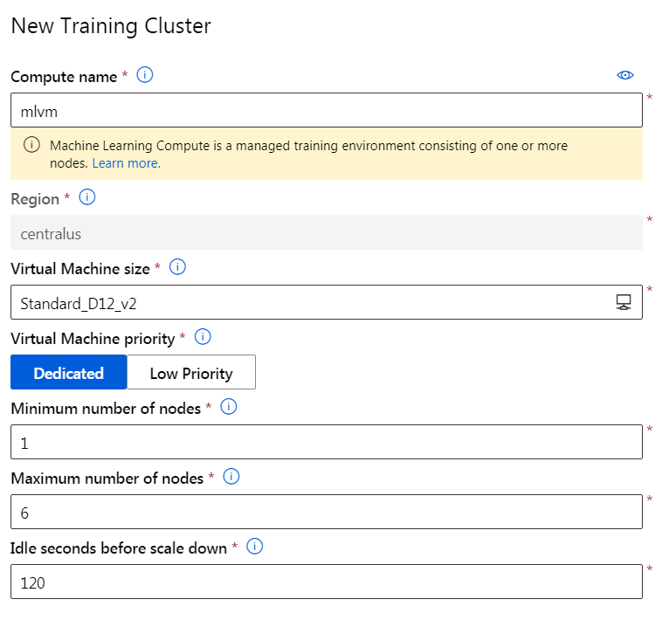

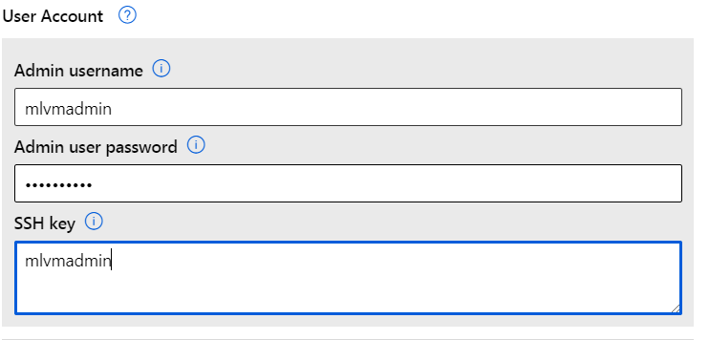

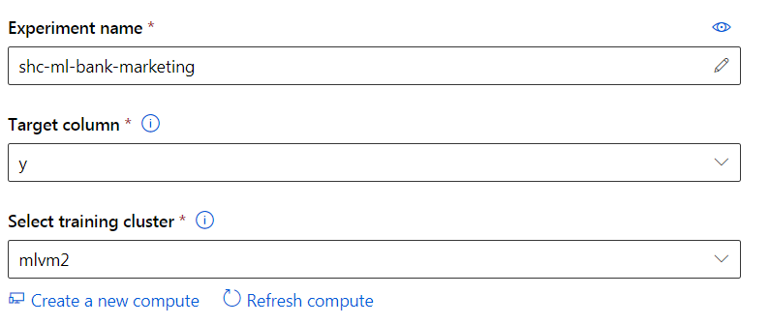

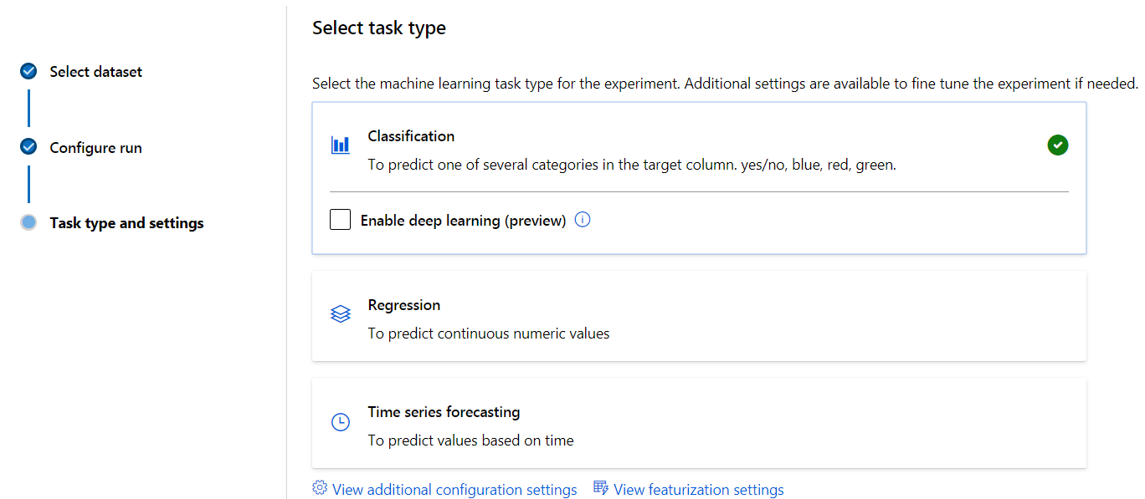

Choose the additional Configuration settings for applying Machine Learning parameters for classification problem

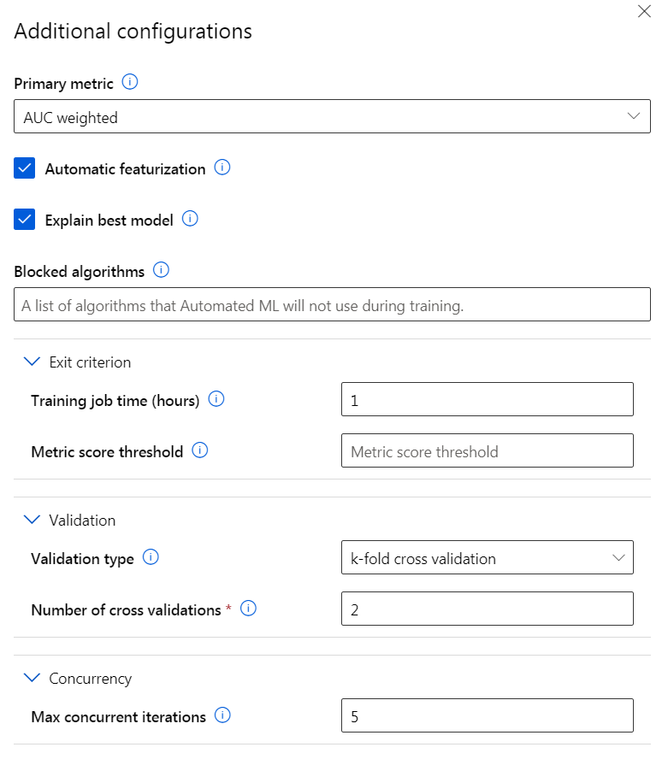

**Explain Each of them**

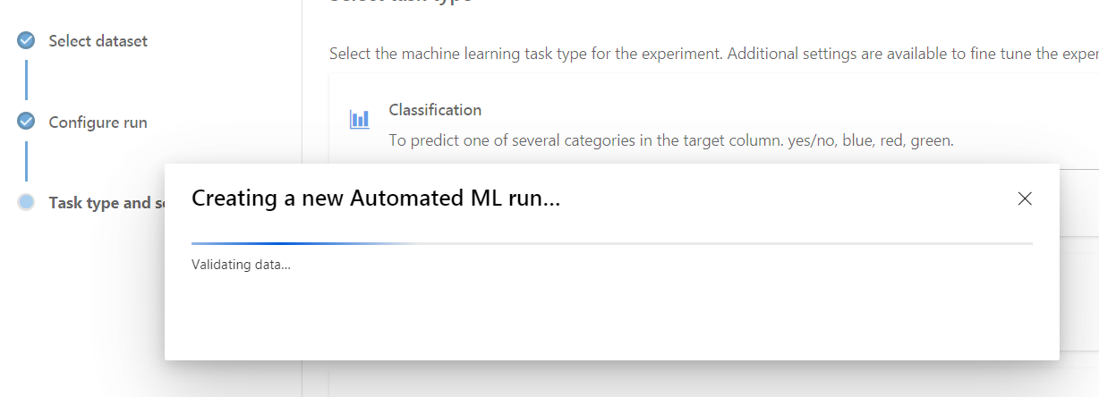

**Experiment Running Status**

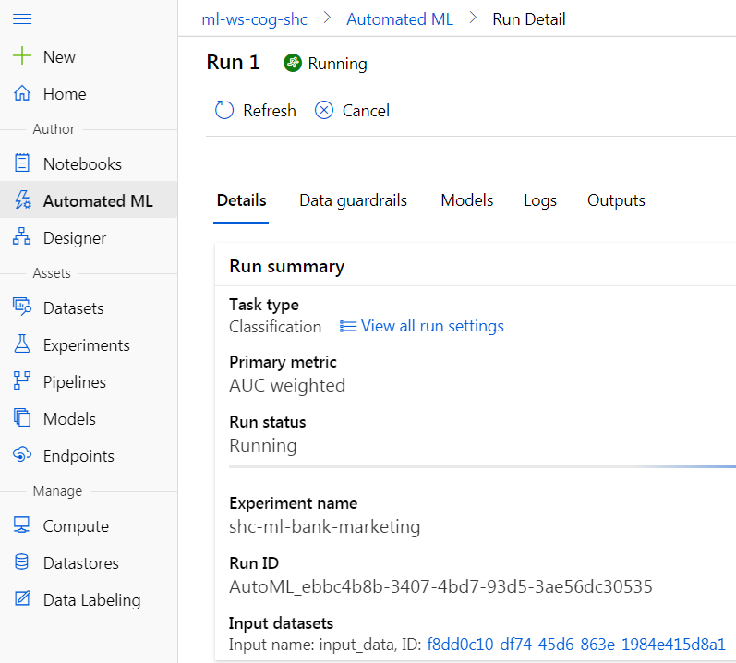

**Model Running Status**

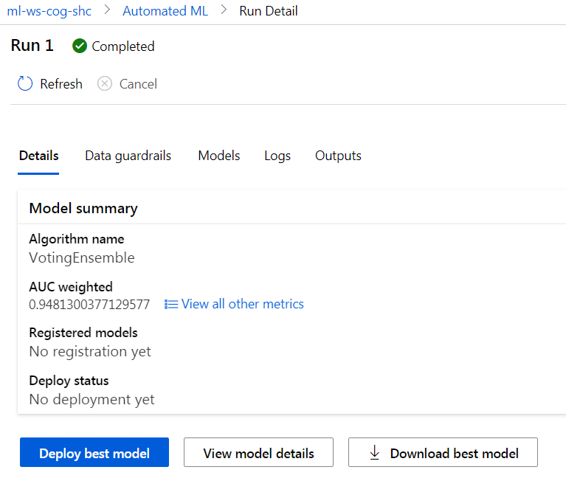

1. **Deployment**

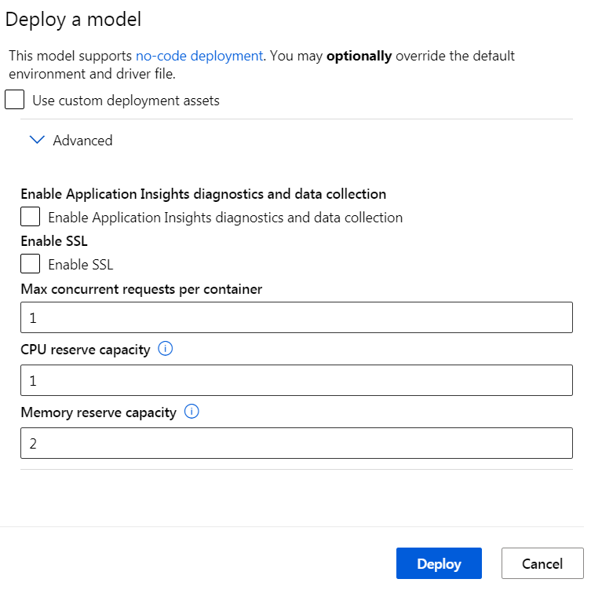

**The endpoint contains all the details about the**

**Data Quality Check**

**Based on the following check the data fed to machine Learning model is verified**

|  |  |
| --- | --- |
| **Type** | Class balancing detection |
| **Status** | Passed |
| **Description** | Classes are balanced in the training data. |
|  |  |
| **Type** | Missing values imputation |
| **Status** | Passed |
| **Description** | There were no missing values found in the training data. |
|  |  |
| **Type** | High cardinality feature detection |
| **Status** | Passed |
| **Description** | Your inputs were analyzed, and no high cardinality features were detected. |

**Testing and Algorithm Performance**

|  |  |  |
| --- | --- | --- |
| **Techniques** | **Score** | **Meaning** |
| Voting Ensemble | 0.9481300377129577 | 94 % Accuracy |
|  |  |  |

**Note: How to understand or interpret these charts**

<https://docs.microsoft.com/en-us/azure/machine-learning/how-to-understand-automated-ml>

Precision Recall

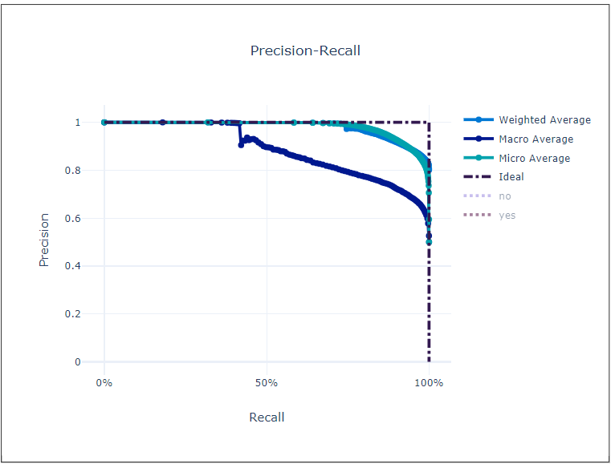

**ROC**

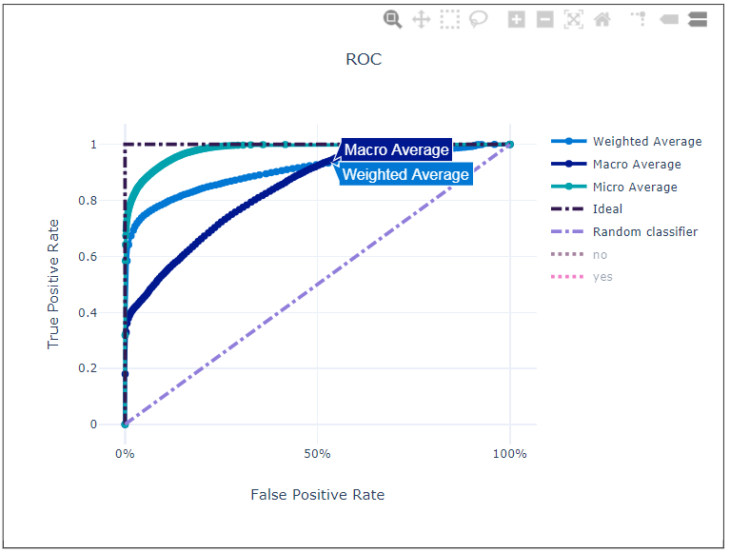

**Calibration Curve**

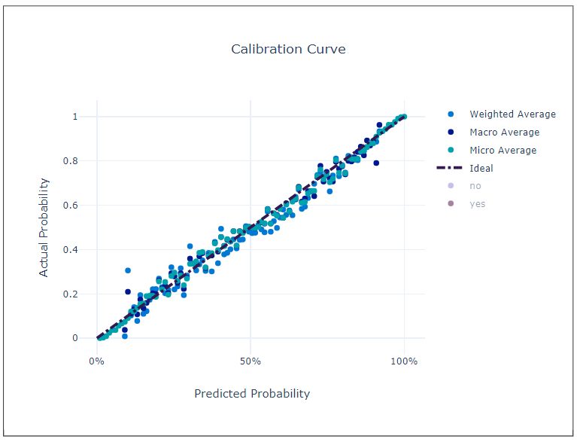

**Lift Curve**

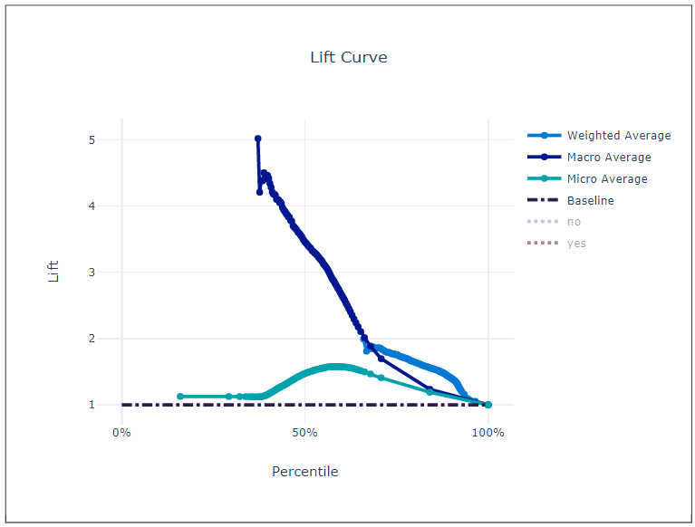

**Gain Curve**

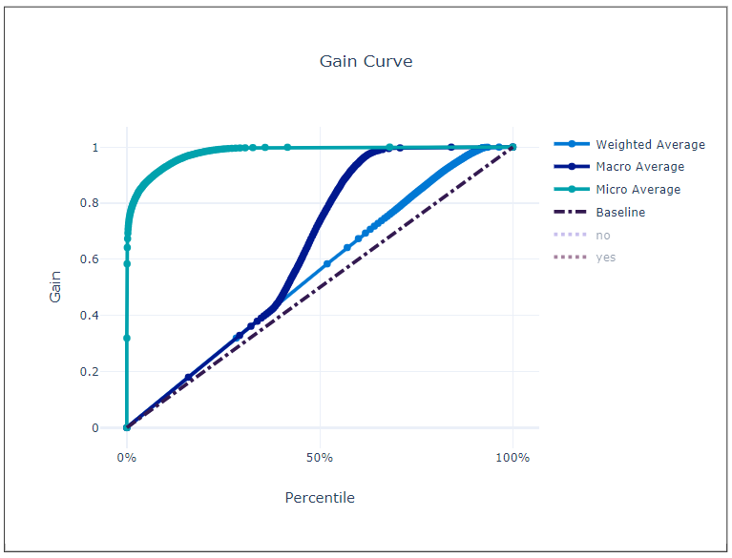

**Confusion Matrix**

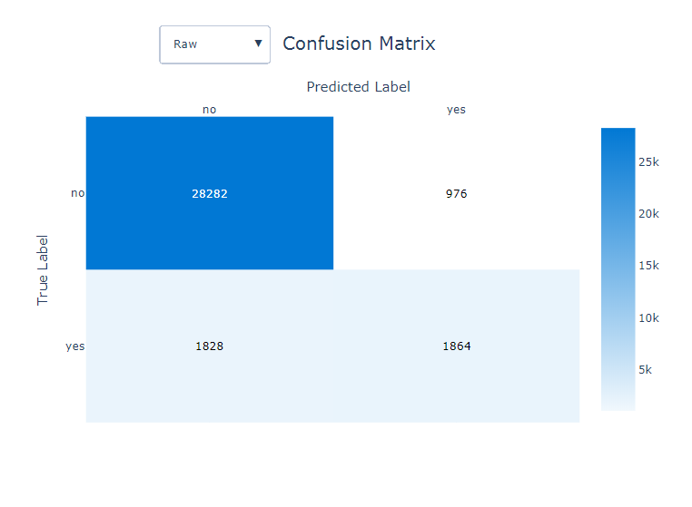

**Results**

[VotingEnsemble](https://ml.azure.com/automl/experiments/id/5f83fd6d-a735-4bb2-bfb7-eaad0825e05e/rundetails/AutoML_ebbc4b8b-3407-4bd7-93d5-3ae56dc30535_44?wsid=/subscriptions/9bdcebed-1f8e-4767-8500-e1300b0d9df7/resourcegroups/rg-cog-shc-ml/workspaces/ml-ws-cog-shc&tid=72f988bf-86f1-41af-91ab-2d7cd011db47) , 0.9481300377129577

StackEnsemble, 0.9477017165451972

[MaxAbsScaler, LightGBM](https://ml.azure.com/automl/experiments/id/5f83fd6d-a735-4bb2-bfb7-eaad0825e05e/rundetails/AutoML_ebbc4b8b-3407-4bd7-93d5-3ae56dc30535_0?wsid=/subscriptions/9bdcebed-1f8e-4767-8500-e1300b0d9df7/resourcegroups/rg-cog-shc-ml/workspaces/ml-ws-cog-shc&tid=72f988bf-86f1-41af-91ab-2d7cd011db47) 0.9460690364071503

[MaxAbsScaler, LightGBM](https://ml.azure.com/automl/experiments/id/5f83fd6d-a735-4bb2-bfb7-eaad0825e05e/rundetails/AutoML_ebbc4b8b-3407-4bd7-93d5-3ae56dc30535_38?wsid=/subscriptions/9bdcebed-1f8e-4767-8500-e1300b0d9df7/resourcegroups/rg-cog-shc-ml/workspaces/ml-ws-cog-shc&tid=72f988bf-86f1-41af-91ab-2d7cd011db47) 0.945913176591541

[StandardScalerWrapper, XGBoostClassifier](https://ml.azure.com/automl/experiments/id/5f83fd6d-a735-4bb2-bfb7-eaad0825e05e/rundetails/AutoML_ebbc4b8b-3407-4bd7-93d5-3ae56dc30535_33?wsid=/subscriptions/9bdcebed-1f8e-4767-8500-e1300b0d9df7/resourcegroups/rg-cog-shc-ml/workspaces/ml-ws-cog-shc&tid=72f988bf-86f1-41af-91ab-2d7cd011db47) 0.9458271801768621

[MaxAbsScaler, LightGBM](https://ml.azure.com/automl/experiments/id/5f83fd6d-a735-4bb2-bfb7-eaad0825e05e/rundetails/AutoML_ebbc4b8b-3407-4bd7-93d5-3ae56dc30535_39?wsid=/subscriptions/9bdcebed-1f8e-4767-8500-e1300b0d9df7/resourcegroups/rg-cog-shc-ml/workspaces/ml-ws-cog-shc&tid=72f988bf-86f1-41af-91ab-2d7cd011db47) 0.9458043031209182

[MaxAbsScaler, XGBoostClassifier](https://ml.azure.com/automl/experiments/id/5f83fd6d-a735-4bb2-bfb7-eaad0825e05e/rundetails/AutoML_ebbc4b8b-3407-4bd7-93d5-3ae56dc30535_1?wsid=/subscriptions/9bdcebed-1f8e-4767-8500-e1300b0d9df7/resourcegroups/rg-cog-shc-ml/workspaces/ml-ws-cog-shc&tid=72f988bf-86f1-41af-91ab-2d7cd011db47) 0.9455842919635098

[StandardScalerWrapper, LightGBM](https://ml.azure.com/automl/experiments/id/5f83fd6d-a735-4bb2-bfb7-eaad0825e05e/rundetails/AutoML_ebbc4b8b-3407-4bd7-93d5-3ae56dc30535_34?wsid=/subscriptions/9bdcebed-1f8e-4767-8500-e1300b0d9df7/resourcegroups/rg-cog-shc-ml/workspaces/ml-ws-cog-shc&tid=72f988bf-86f1-41af-91ab-2d7cd011db47) 0.9454938431907515

[StandardScalerWrapper, XGBoostClassifier](https://ml.azure.com/automl/experiments/id/5f83fd6d-a735-4bb2-bfb7-eaad0825e05e/rundetails/AutoML_ebbc4b8b-3407-4bd7-93d5-3ae56dc30535_32?wsid=/subscriptions/9bdcebed-1f8e-4767-8500-e1300b0d9df7/resourcegroups/rg-cog-shc-ml/workspaces/ml-ws-cog-shc&tid=72f988bf-86f1-41af-91ab-2d7cd011db47) 0.9452164814600048

[StandardScalerWrapper, XGBoostClassifier](https://ml.azure.com/automl/experiments/id/5f83fd6d-a735-4bb2-bfb7-eaad0825e05e/rundetails/AutoML_ebbc4b8b-3407-4bd7-93d5-3ae56dc30535_36?wsid=/subscriptions/9bdcebed-1f8e-4767-8500-e1300b0d9df7/resourcegroups/rg-cog-shc-ml/workspaces/ml-ws-cog-shc&tid=72f988bf-86f1-41af-91ab-2d7cd011db47) 0.944980161117106

[StandardScalerWrapper, XGBoostClassifier](https://ml.azure.com/automl/experiments/id/5f83fd6d-a735-4bb2-bfb7-eaad0825e05e/rundetails/AutoML_ebbc4b8b-3407-4bd7-93d5-3ae56dc30535_26?wsid=/subscriptions/9bdcebed-1f8e-4767-8500-e1300b0d9df7/resourcegroups/rg-cog-shc-ml/workspaces/ml-ws-cog-shc&tid=72f988bf-86f1-41af-91ab-2d7cd011db47) 0.9449310250369665

[StandardScalerWrapper, XGBoostClassifier](https://ml.azure.com/automl/experiments/id/5f83fd6d-a735-4bb2-bfb7-eaad0825e05e/rundetails/AutoML_ebbc4b8b-3407-4bd7-93d5-3ae56dc30535_28?wsid=/subscriptions/9bdcebed-1f8e-4767-8500-e1300b0d9df7/resourcegroups/rg-cog-shc-ml/workspaces/ml-ws-cog-shc&tid=72f988bf-86f1-41af-91ab-2d7cd011db47) 0.9449022246774181

[MaxAbsScaler, LightGBM](https://ml.azure.com/automl/experiments/id/5f83fd6d-a735-4bb2-bfb7-eaad0825e05e/rundetails/AutoML_ebbc4b8b-3407-4bd7-93d5-3ae56dc30535_25?wsid=/subscriptions/9bdcebed-1f8e-4767-8500-e1300b0d9df7/resourcegroups/rg-cog-shc-ml/workspaces/ml-ws-cog-shc&tid=72f988bf-86f1-41af-91ab-2d7cd011db47) 0.9447888091556007

[StandardScalerWrapper, XGBoostClassifier](https://ml.azure.com/automl/experiments/id/5f83fd6d-a735-4bb2-bfb7-eaad0825e05e/rundetails/AutoML_ebbc4b8b-3407-4bd7-93d5-3ae56dc30535_11?wsid=/subscriptions/9bdcebed-1f8e-4767-8500-e1300b0d9df7/resourcegroups/rg-cog-shc-ml/workspaces/ml-ws-cog-shc&tid=72f988bf-86f1-41af-91ab-2d7cd011db47) 0.9439304329070115

[MaxAbsScaler, LightGBM](https://ml.azure.com/automl/experiments/id/5f83fd6d-a735-4bb2-bfb7-eaad0825e05e/rundetails/AutoML_ebbc4b8b-3407-4bd7-93d5-3ae56dc30535_29?wsid=/subscriptions/9bdcebed-1f8e-4767-8500-e1300b0d9df7/resourcegroups/rg-cog-shc-ml/workspaces/ml-ws-cog-shc&tid=72f988bf-86f1-41af-91ab-2d7cd011db47) 0.9439173088313175

[StandardScalerWrapper, XGBoostClassifier](https://ml.azure.com/automl/experiments/id/5f83fd6d-a735-4bb2-bfb7-eaad0825e05e/rundetails/AutoML_ebbc4b8b-3407-4bd7-93d5-3ae56dc30535_27?wsid=/subscriptions/9bdcebed-1f8e-4767-8500-e1300b0d9df7/resourcegroups/rg-cog-shc-ml/workspaces/ml-ws-cog-shc&tid=72f988bf-86f1-41af-91ab-2d7cd011db47) 0.9434982824144305

[StandardScalerWrapper, XGBoostClassifier](https://ml.azure.com/automl/experiments/id/5f83fd6d-a735-4bb2-bfb7-eaad0825e05e/rundetails/AutoML_ebbc4b8b-3407-4bd7-93d5-3ae56dc30535_37?wsid=/subscriptions/9bdcebed-1f8e-4767-8500-e1300b0d9df7/resourcegroups/rg-cog-shc-ml/workspaces/ml-ws-cog-shc&tid=72f988bf-86f1-41af-91ab-2d7cd011db47) 0.9411444447531485

[MaxAbsScaler, LightGBM](https://ml.azure.com/automl/experiments/id/5f83fd6d-a735-4bb2-bfb7-eaad0825e05e/rundetails/AutoML_ebbc4b8b-3407-4bd7-93d5-3ae56dc30535_17?wsid=/subscriptions/9bdcebed-1f8e-4767-8500-e1300b0d9df7/resourcegroups/rg-cog-shc-ml/workspaces/ml-ws-cog-shc&tid=72f988bf-86f1-41af-91ab-2d7cd011db47) 0.9407442142208221

[StandardScalerWrapper, XGBoostClassifier](https://ml.azure.com/automl/experiments/id/5f83fd6d-a735-4bb2-bfb7-eaad0825e05e/rundetails/AutoML_ebbc4b8b-3407-4bd7-93d5-3ae56dc30535_3?wsid=/subscriptions/9bdcebed-1f8e-4767-8500-e1300b0d9df7/resourcegroups/rg-cog-shc-ml/workspaces/ml-ws-cog-shc&tid=72f988bf-86f1-41af-91ab-2d7cd011db47) 0.9407016084901154

[StandardScalerWrapper, XGBoostClassifier](https://ml.azure.com/automl/experiments/id/5f83fd6d-a735-4bb2-bfb7-eaad0825e05e/rundetails/AutoML_ebbc4b8b-3407-4bd7-93d5-3ae56dc30535_24?wsid=/subscriptions/9bdcebed-1f8e-4767-8500-e1300b0d9df7/resourcegroups/rg-cog-shc-ml/workspaces/ml-ws-cog-shc&tid=72f988bf-86f1-41af-91ab-2d7cd011db47) 0.9397281180030277